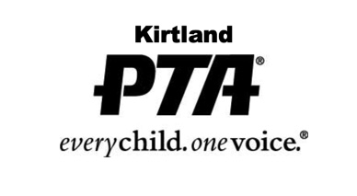

January 21, 2020

Dear Kirtland Seniors,

It is our pleasure to announce that this year the Kirtland PTA is offering 3 scholarships in the amount of $1,000 each. The purpose of the PTA Scholarship is to encourage students to continue their education, and we strongly urge all seniors to apply.

The selection process is kept completely anonymous; scholarships are reviewed by a Scholarship Committee that consists of educators and PTA members. The following criteria are taken into consideration when reviewing scholarships: overall coursework, outstanding achievements/characteristics, extracurricular activities, community participation/service, outside work and personal recommendations.

Attached is the 2020 PTA Scholarship form. The completed form and all applicable attachments should be returned by Friday, April 3, 2020 to:

PTA Scholarship Committee
Kirtland Elementary School
9140 Chillicothe Road
Kirtland, Ohio 44094

Please keep copies of all paperwork submitted for your records.

Thank you and we look forward to hearing from KHS seniors! Good luck!

Sincerely,

Allison Wuliger
Kirtland PTA President
kirtlandhornetpta@gmail.com

Date:
Name of Student: __________________________________
Address: _________________________________________
Phone Number: _________________
Email: ________________________
GPA at end of Fall & Winter Semesters __________/_________
AP, Post Secondary, Vocational or Weighted Courses taken:
_______________________________________________
_______________________________________________
_______________________________________________
Honors: _______________________________________________
_______________________________________________
_______________________________________________

Hobbies or Interests:
_______________________________________________
_______________________________________________

School Activities, Leadership and Service:
_____________________________________________________________________________________________________________________________________________

Community Activities, Leadership and Service:
_____________________________________________________________________________________________________________________________________________
As for graduation, 16 service hours are required to qualify for a PTA scholarship. It is not necessary to have these service hours in the area of PTA; however, PTA service hours will weigh more heavily in the decision making process. If you have volunteered to help at any PTA event(s), please list the total number of hours you’ve participated:
PTA Event: ____________________ Hours: ______________
PTA Event: ____________________ Hours: ______________
PTA Event: ____________________ Hours: ______________
PTA Event: ____________________ Hours: ______________

Employment: _______________________________________________
College or Technical Program planning to attend:
_______________________________________________
Anticipated Major:
_______________________________________________

Include two letters of reference from individuals who are not members of your immediate family.

Please attach a one-page summary (no less than 200 words, no more than 500) of why you qualify to be a recipient of the PTA scholarship, i.e. G.P.A., Scholastic Awards, Community Service Awards.

