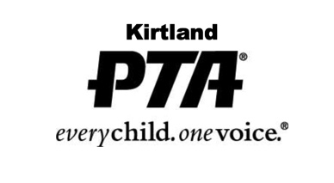

January 19, 2021

Dear Kirtland Seniors,

It is our pleasure to announce that this year the Kirtland PTA is offering 3 scholarships in the amount of $1,000 each to KHS seniors. The purpose of the PTA Scholarship is to encourage graduating students to continue their education, and we strongly urge all seniors to apply.

The selection process is kept completely anonymous and scholarships are reviewed by a Scholarship Committee that consists of educators and PTA members. The following criteria are taken into consideration when reviewing scholarships: overall coursework, outstanding achievements/characteristics, extracurricular activities, community participation/service, outside work and personal recommendations.

Attached is the 2021 PTA Scholarship application form. The completed form and all applicable attachments should be emailed by Monday, April 5, 2021 to: kirtlandhornetpta@gmail.com

Please keep copies of all paperwork submitted for your records.

Thank you and we look forward to hearing from you! Best of luck!

Sincerely,

Allison Wuliger

Allison Wuliger
Kirtland PTA President
kirtlandhornetpta@gmail.com

Date:
Name of Student:
Address:
Phone Number:
Email:
1st Quarter Term GPA:
2nd Quarter Term GPA:
Cumulative GPA:
AP, Post Secondary, Vocational or Weighted Courses taken:

Honors:

Hobbies or Interests:

School Activities, Leadership and Service:

Community Activities, Leadership and Service:

Similar to graduation, 16 service hours are required to qualify for a PTA scholarship. Please list your service activities and the number of hours. If you have volunteered to help at any PTA event(s), please specify and list the total number of hours you volunteered:

Employment:

College or Technical Program planning to attend:

Anticipated Major:

Please include two letters of recommendation from individuals who are not members of your immediate family.

Please attach a one-page summary (no less than 200 words, no more than 500) of why you qualify to be a recipient of the PTA scholarship, i.e. G.P.A., Scholastic Awards, Community Service Awards.

